**3.3 Project Work**

**Kool Screen [Flutter Wallpaper App]**

Kool Screen is a Flutter wallpaper app that provides users with an extensive collection of high-quality wallpapers from Pexels. With its intuitive user interface and seamless user experience, Kool Screen allows users to personalize their devices with ease. The app features a wide range of wallpaper categories, including nature, abstract, sports, and movies, and users can search for wallpapers based on keywords, colors, and orientation. The app also includes customization options, social media sharing capabilities, and the ability to download wallpapers for offline use.

One of the key features of Kool Screen is its integration with the Pexels API. The API provides the app with a vast collection of high-quality wallpapers, ensuring that users always have access to fresh and exciting content. The integration with the Pexels API also enables users to search for wallpapers based on various criteria, including color and orientation. This feature ensures that users can find wallpapers that match their preferences and complement their device's design.

The app's user interface is designed to be simple and easy to navigate, allowing users to quickly find the wallpapers they want. The app's search and category features make it easy for users to discover new wallpapers and keep their wallpaper collection fresh. The app also includes customization options, allowing users to crop or resize wallpapers to fit their device's screen, ensuring a perfect fit every time.

Overall, Kool Screen is an excellent option for users looking to personalize their devices with high-quality wallpapers. Its seamless user experience, extensive collection of wallpapers, and customization options make it an ideal choice for anyone looking to spice up their device's wallpaper collection. With its integration with the Pexels API, users can rest assured that they always have access to fresh and exciting content.

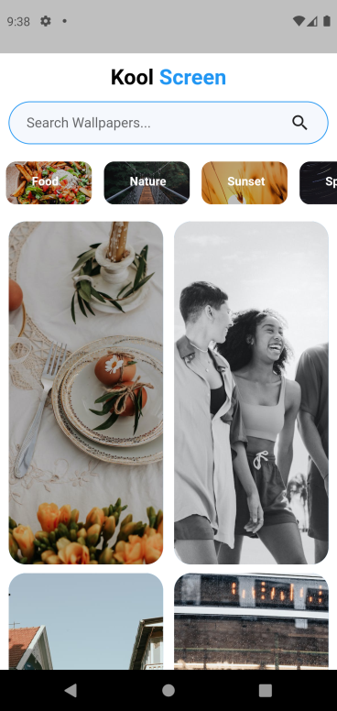

**Figure 3.3.1: Home Section**

The home section of the app contains vast collection of high-quality wallpapers, ensuring that users always have access to fresh and exciting content.

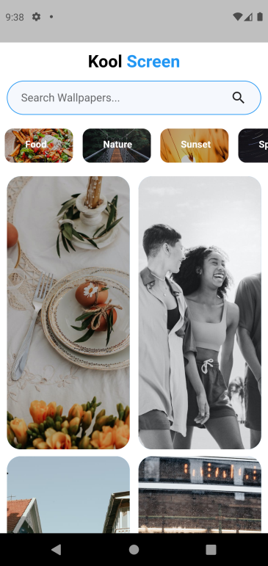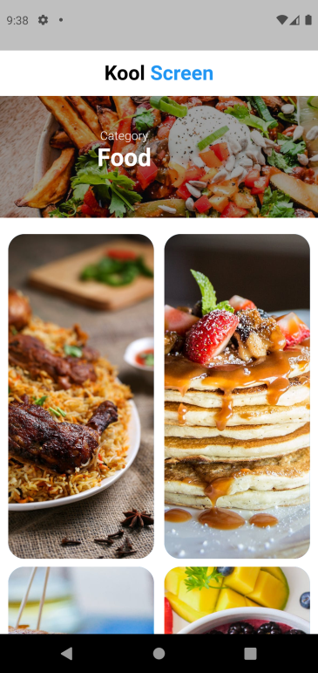

**Figure 3.3.2: Category Section**

The app's category features make it easy for users to discover new trending category wallpapers and keep their wallpaper collection fresh.

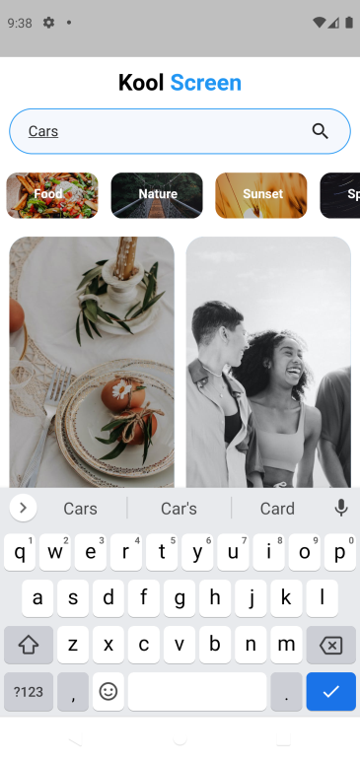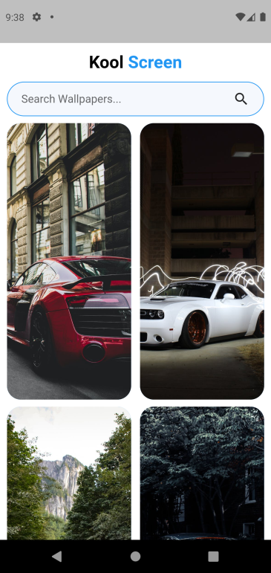

**Figure 3.3.3: Search Section**

The app’s search feature makes it easy for users to search wallpapers based on their own visual taste and various criteria, including colours and orientation etc.



**Figure 3.3.4: Save Wallpaper Section**

The app provides “Save Wallpaper” option which helps users to save their most liked wallpaper into their device gallery and then customize accordingly and set their mobile wallpaper, ensuring a perfect fit every time.